

**DEPARTMENT OF COMPUTER SCIENCE AND ENGINEERING**

**Course Code: CSE491**

**Name: Mashfiq Shahriar Zaman**

**ID: 17301167**

**Email: mashfiq.shahriar.zaman@g.bracu.ac.bd**

***Project Title***: Food Ordering App

https://drive.google.com/drive/folders/1xlAerzfDbFXO7hGKaS6wmN4z8qwK_kRi?usp=sharing

***Project Features:***

Dear Sir, with due respect I have added the proposed features along with some other features:

1. Welcome Screen

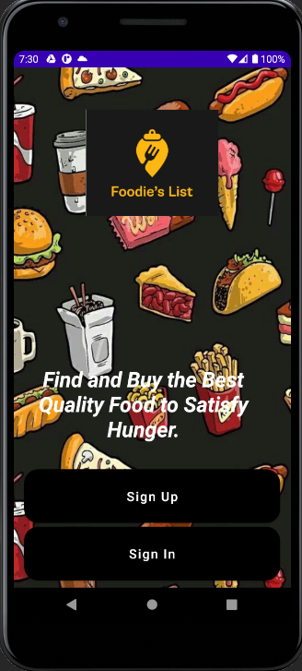

1. User Sign Up Feature:

Adding New User

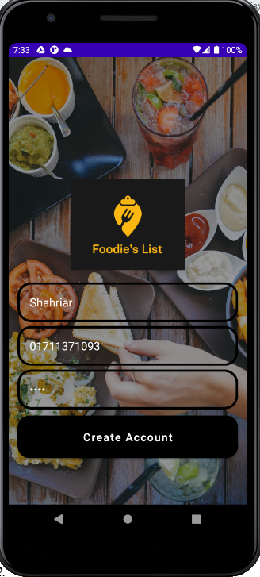

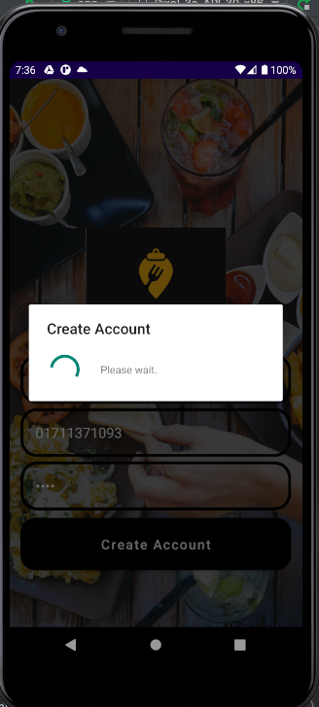

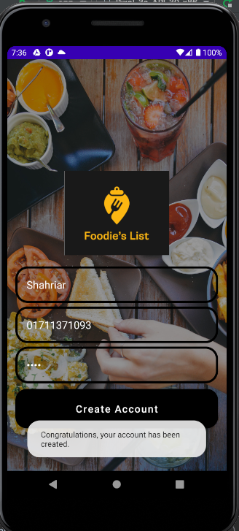

Firebase Database after adding the new user into the User Table:

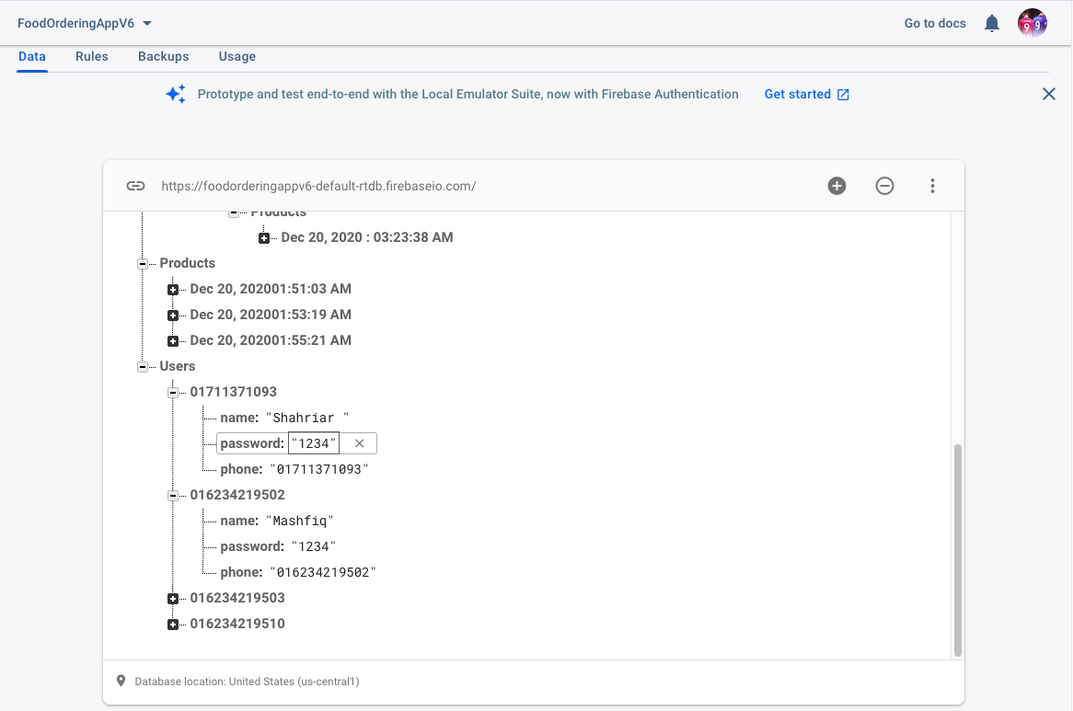

1. User Sign In Feature:

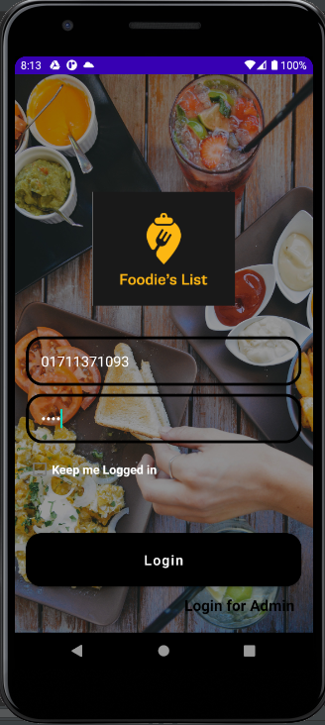

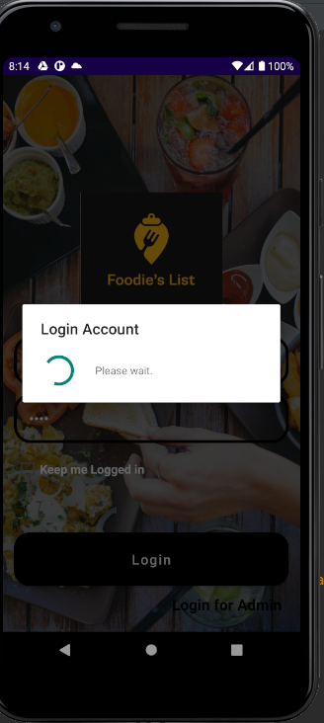

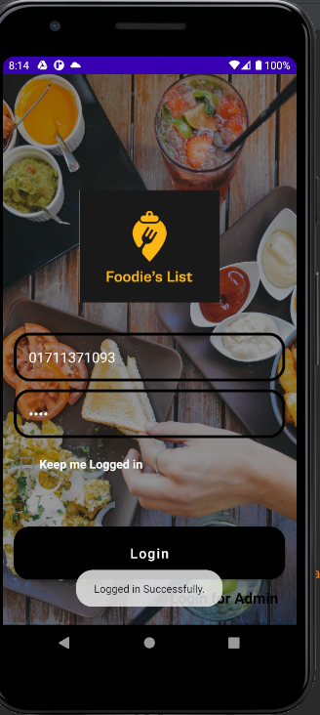

1. Admin Login In Feature:

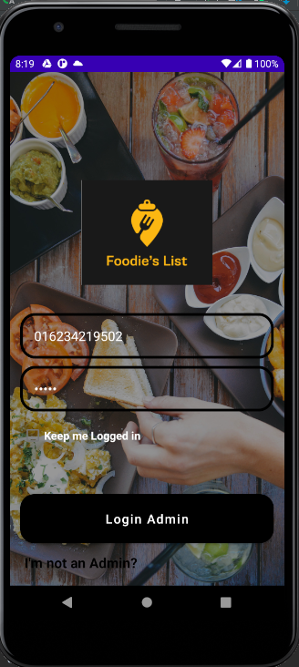

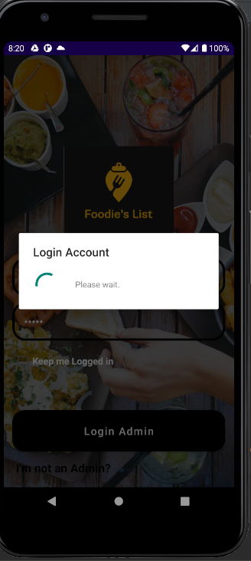

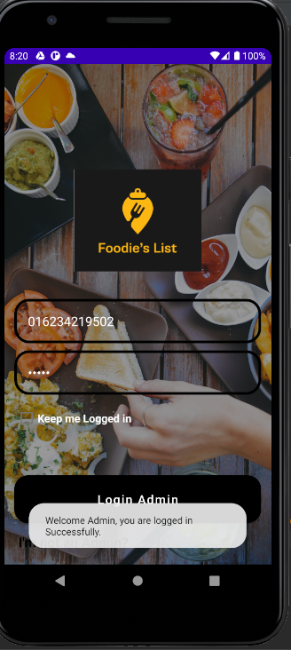

Admin has only Sign In feature not Sign Up:

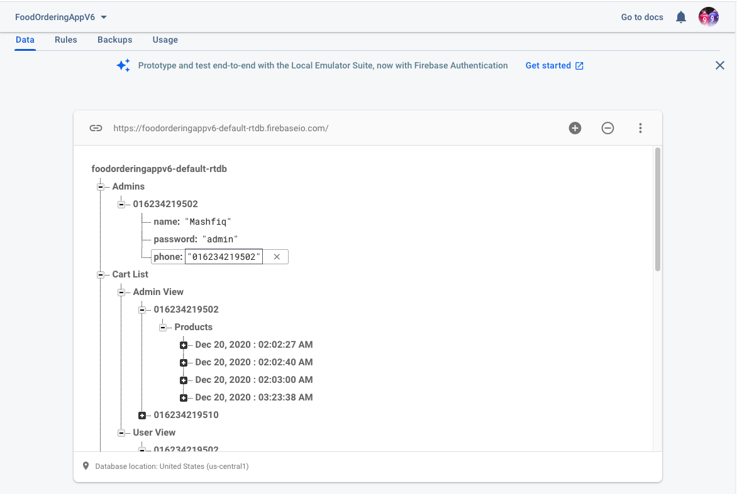

1. Admin Home Screen:

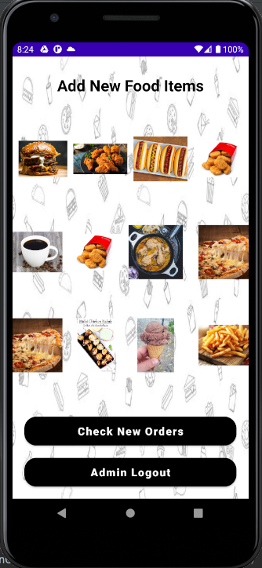

1. Admin Add New Food Item Feature:

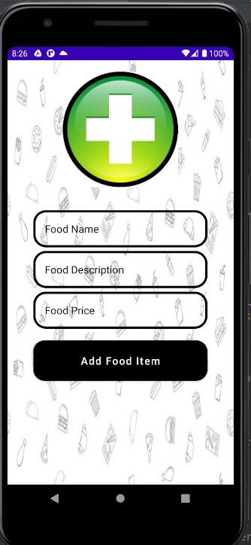

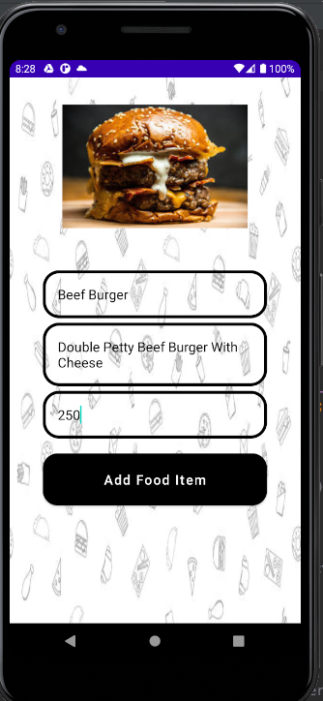

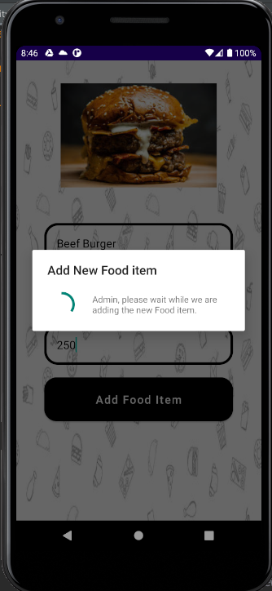

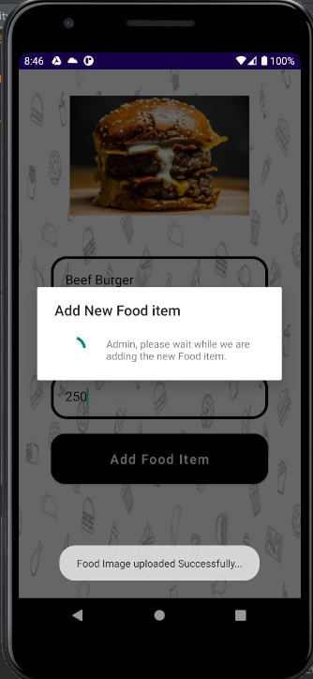

After adding new food items by the Admin, the food item will be stored in the Products table:

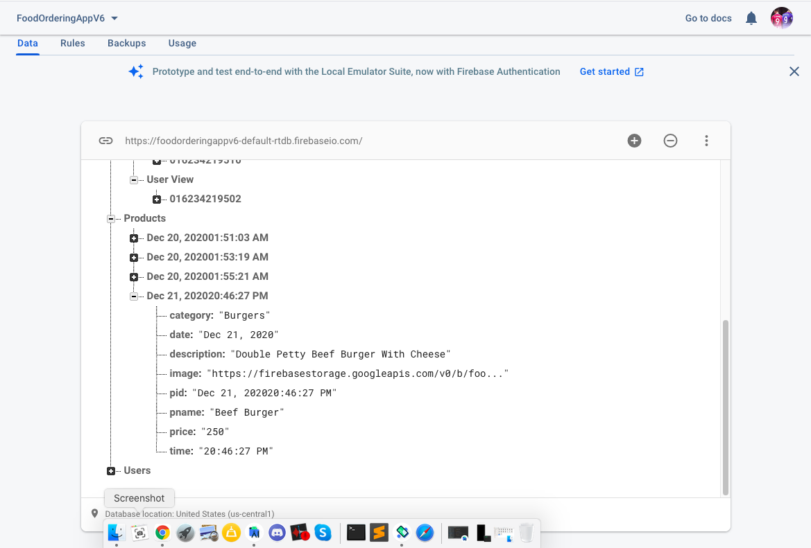

1. User Viewing Food Items Feature:

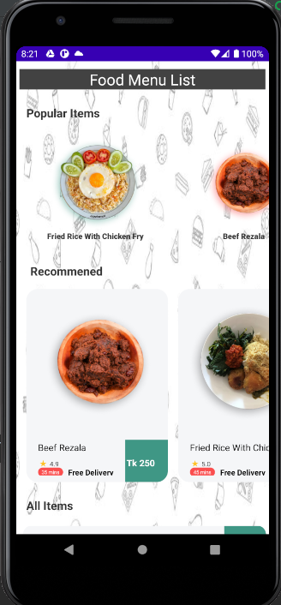

The whole menu has been divided into three segments: Popular item, Recommended section and All items.

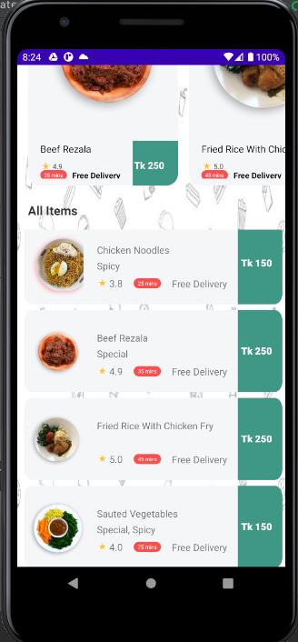

1. User Add to Cart Feature:

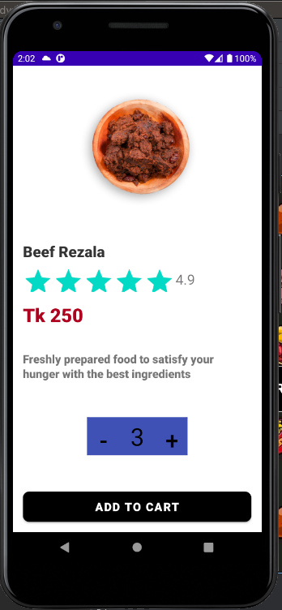

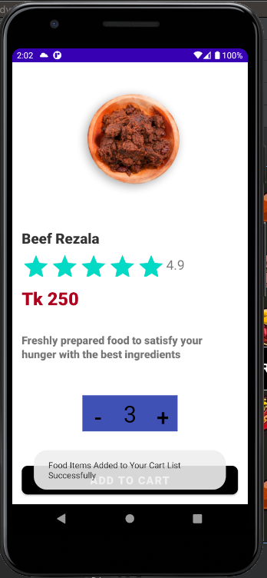

The added items will be stored in the Cart List under the User View :

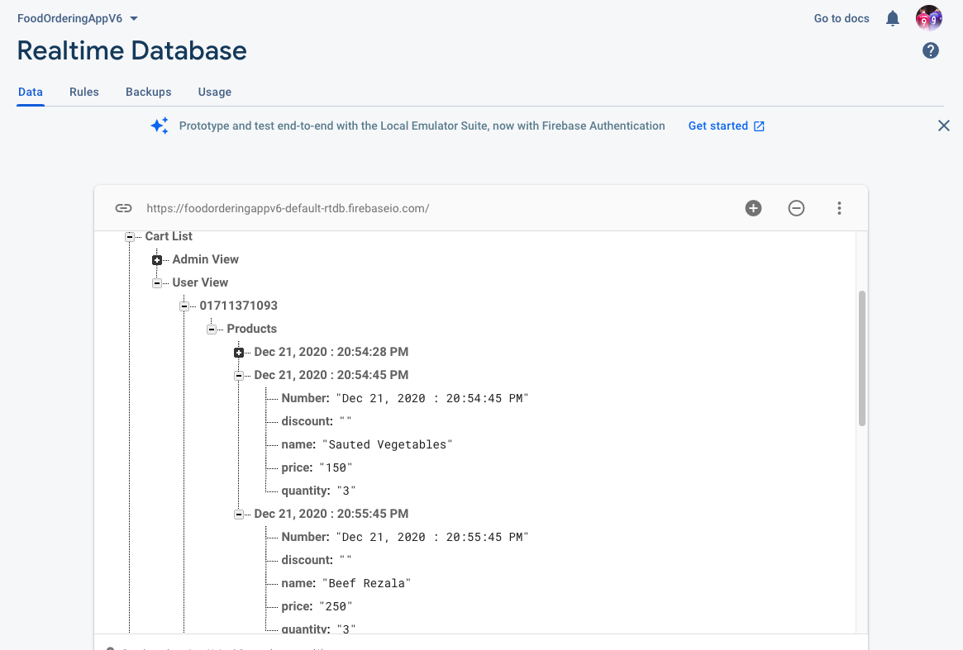

1. User viewing the Order History and Showing the Total Bill feature:

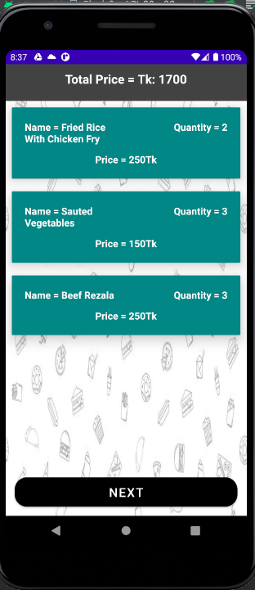

1. User Confirming Order Feature:

After viewing the order history, the user will press the next button and after providing the information the order will be confirmed.

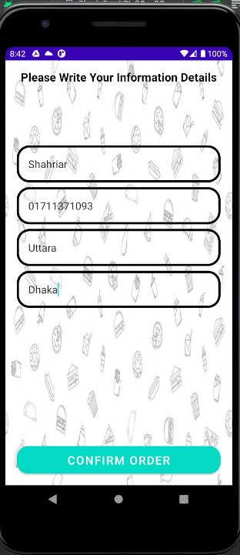

After confirming the order, it will be stored in the Orders table of the firebase database:

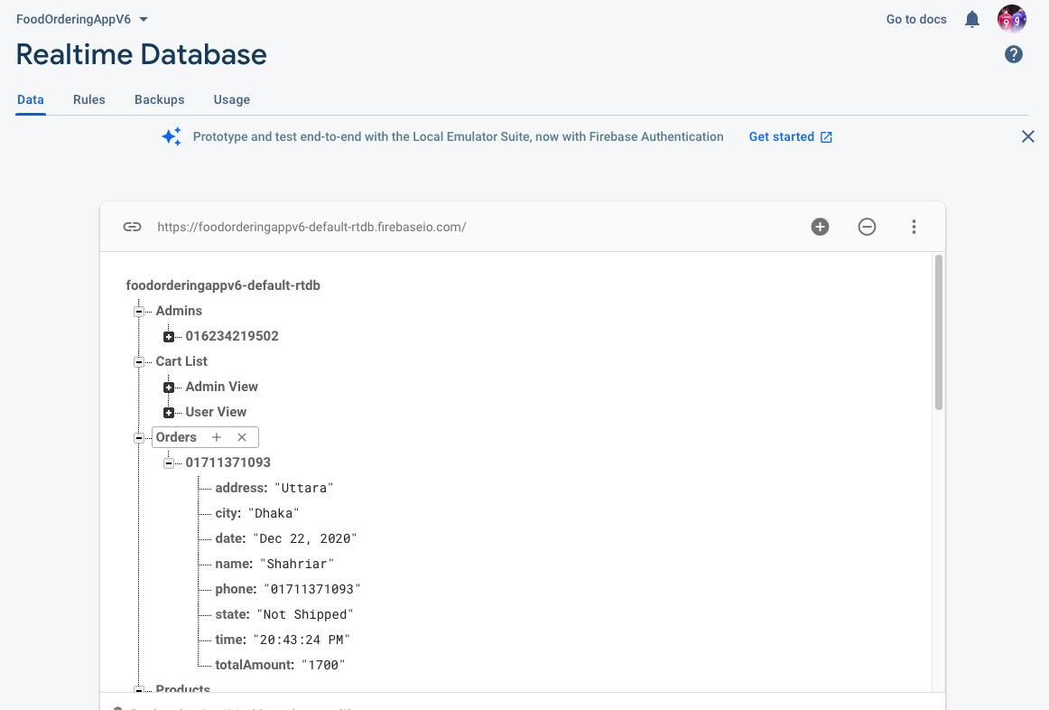

1. Showing the Order Status Feature:

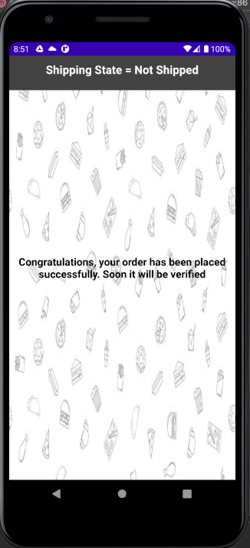

1. Admin Viewing the Confirmed Orders:

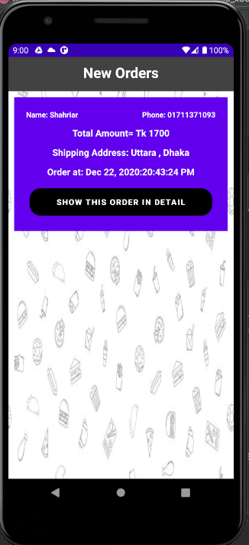

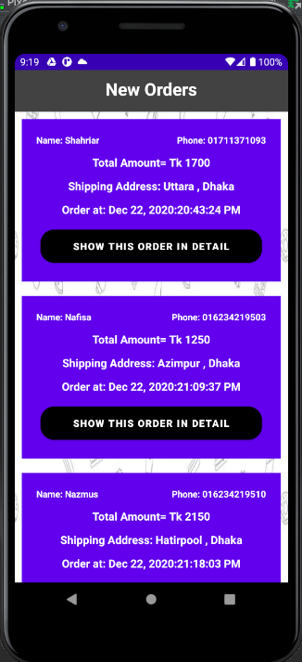

Admin can also view the orders in detail

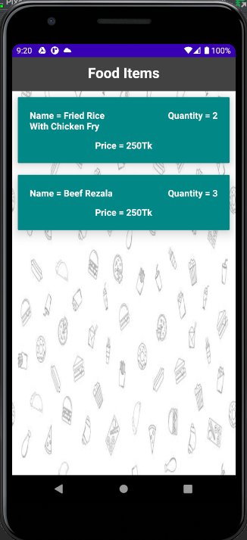

1. Admin can discard the order after it has been shipped:

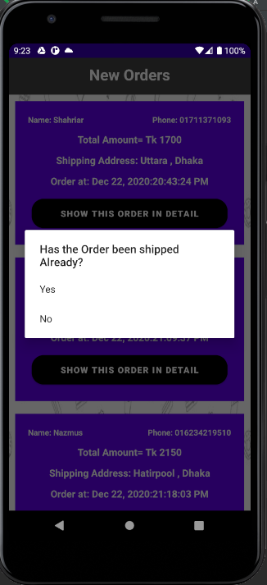

After the Admin pressing the Yes Button, the order will be removed from the Order List of the Admin and the user will again able to add item to the cart :

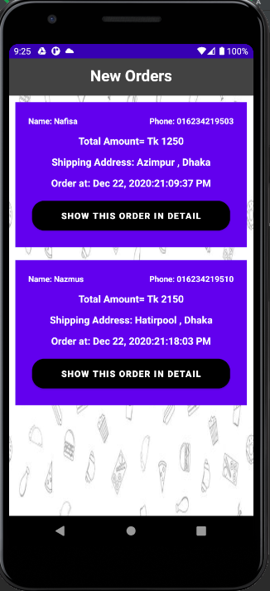

n) Users Name will be Shown in the Navigation:

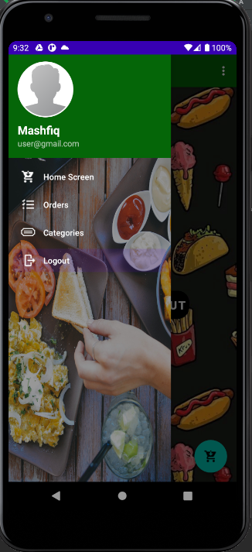

o) User Logout Feature:

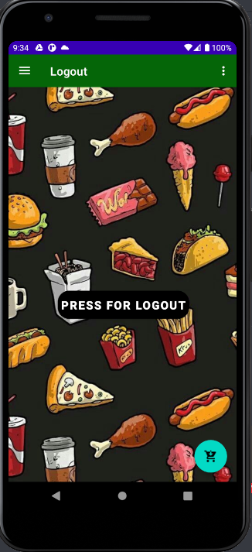

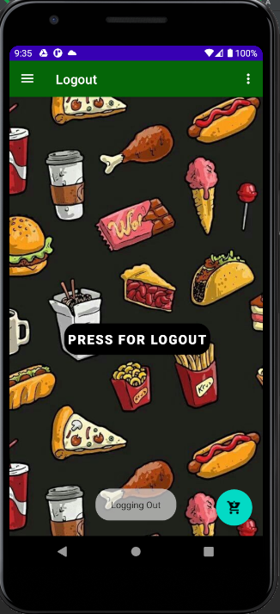

p) Admin Logout Feature:

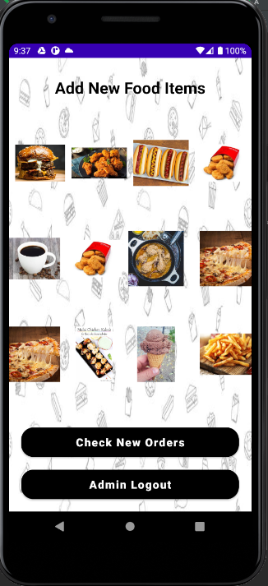

***Online Resources used:***

**a)** *Reference:*

* *https://guides.codepath.com/android/using-the-recyclerview*
* *Youtube videos:* [*https://youtu.be/ED7Z5DCPKCE*](https://youtu.be/ED7Z5DCPKCE)*,* [*https://youtu.be/k0Xe3DaFdL4*](https://youtu.be/k0Xe3DaFdL4)*,* [*https://youtu.be/vyMH0NsY4q4*](https://youtu.be/vyMH0NsY4q4)*,* [*https://youtu.be/QgfNl541oso*](https://youtu.be/QgfNl541oso)*,* [*https://youtu.be/wa8OrQ_e76M*](https://youtu.be/wa8OrQ_e76M)*,* [*https://youtu.be/lnidtzL71ZA*](https://youtu.be/lnidtzL71ZA)*,* [*https://youtu.be/7vTbRZZORog*](https://youtu.be/7vTbRZZORog)*,* [*https://youtu.be/Nw9JF55LDzE*](https://youtu.be/Nw9JF55LDzE)*,* [*https://youtu.be/x-2qtxmxYE8*](https://youtu.be/x-2qtxmxYE8)*,* [*https://youtu.be/XactTKR0Wfc*](https://youtu.be/XactTKR0Wfc)*,* [*https://youtu.be/w4USF9e7b4U*](https://youtu.be/w4USF9e7b4U) *.*

**b)** *Firebase Connection Tutorial*

[*https://developer.android.com/studio/write/firebase*](https://developer.android.com/studio/write/firebase)

***Future Enhancements:***

Following enhancement can be added to the current system which will improve the system.

1. Users can add feedback or comments to the food item.
2. Add forget password feature for the user.